Assignment – 2.2

Name: pooja chittaluri
Roll Number: 2303A51186
Batch - 03
AI Assisted Coding
13-01-2026
Task 1: Cleaning Sensor Data
❖ Scenario:
❖ You are cleaning IoT sensor data where negative values are invalid.
❖ Task:
Use Gemini in Colab to generate a function that filters out all negative
numbers from a list.
❖ Expected Output:
➢ Before/after list
➢ Screenshot of Colab execution
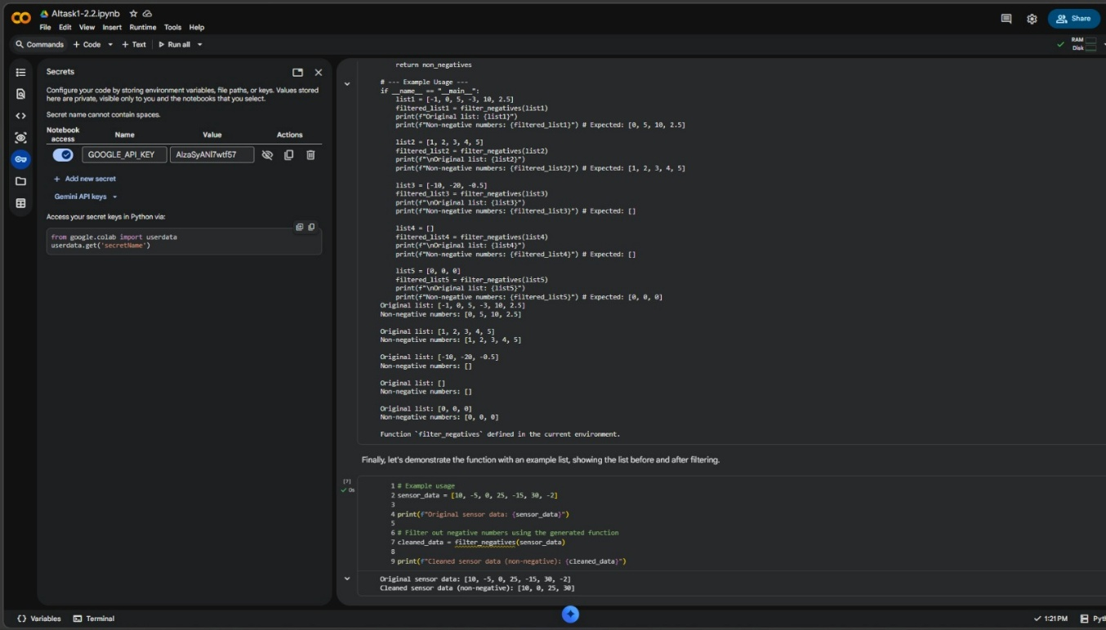
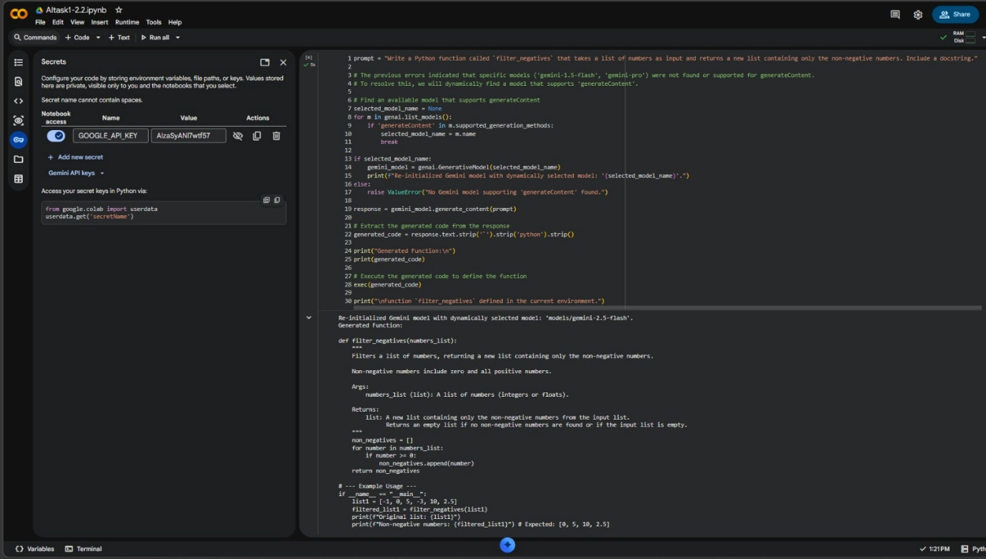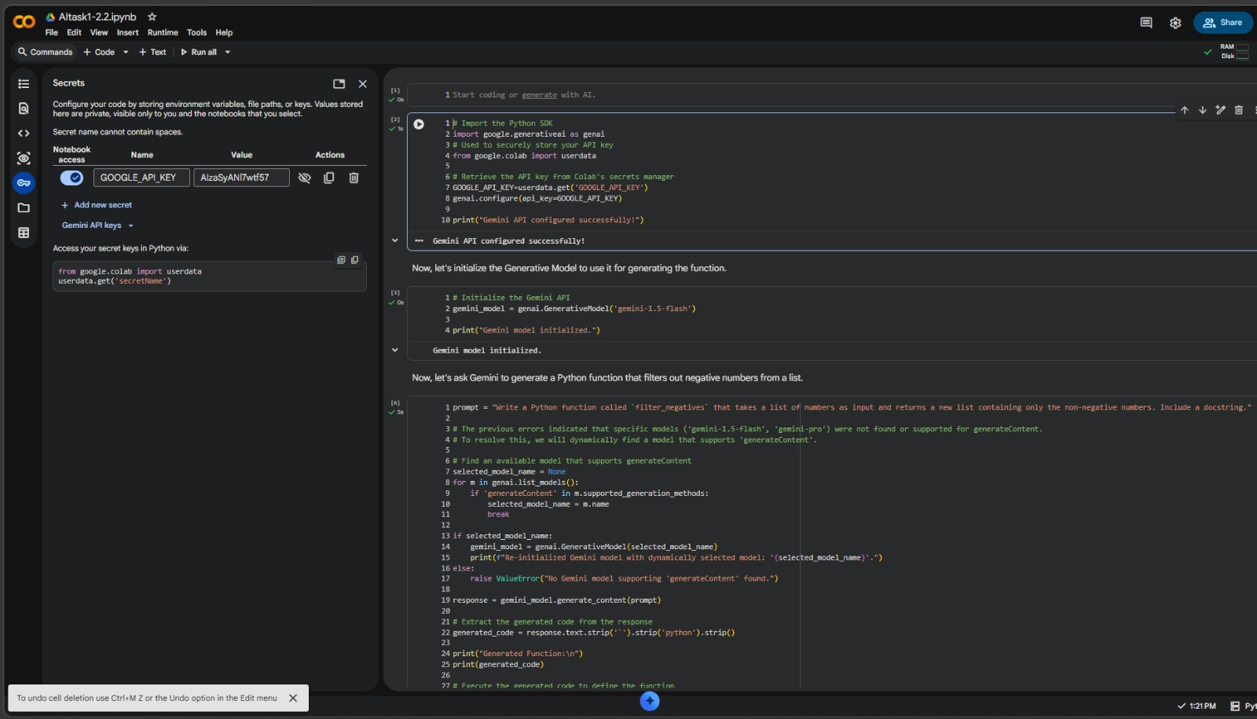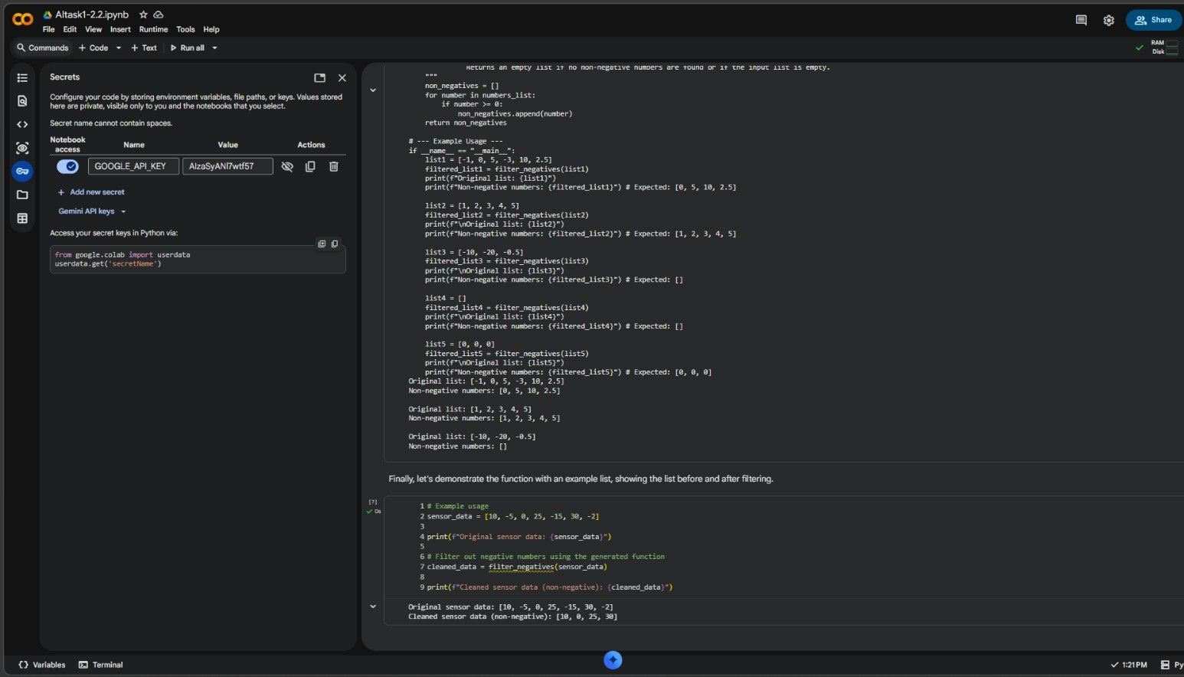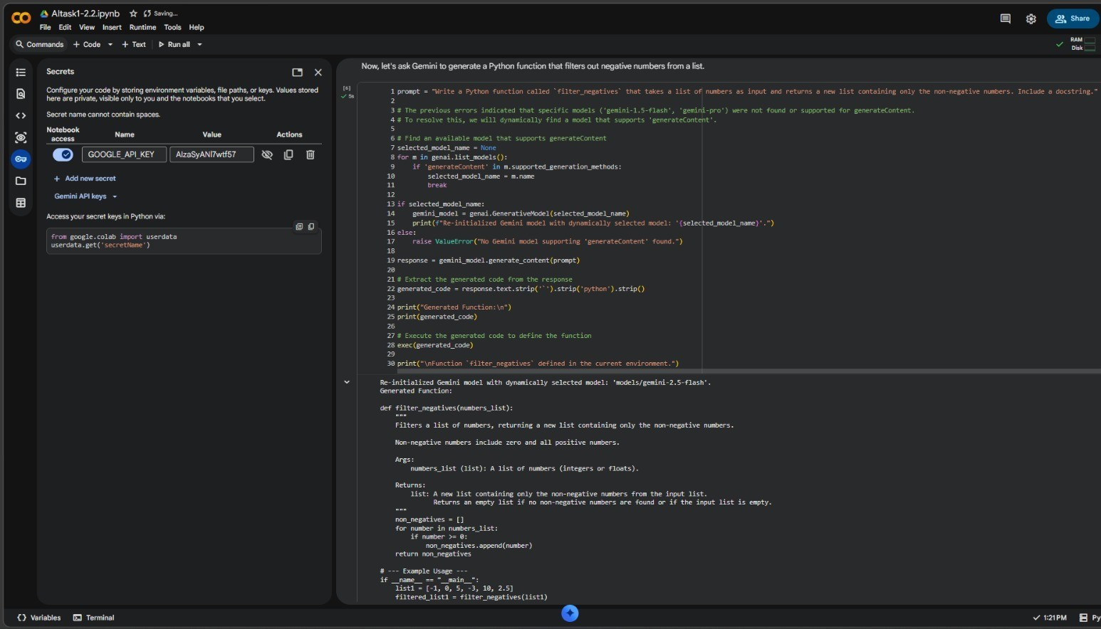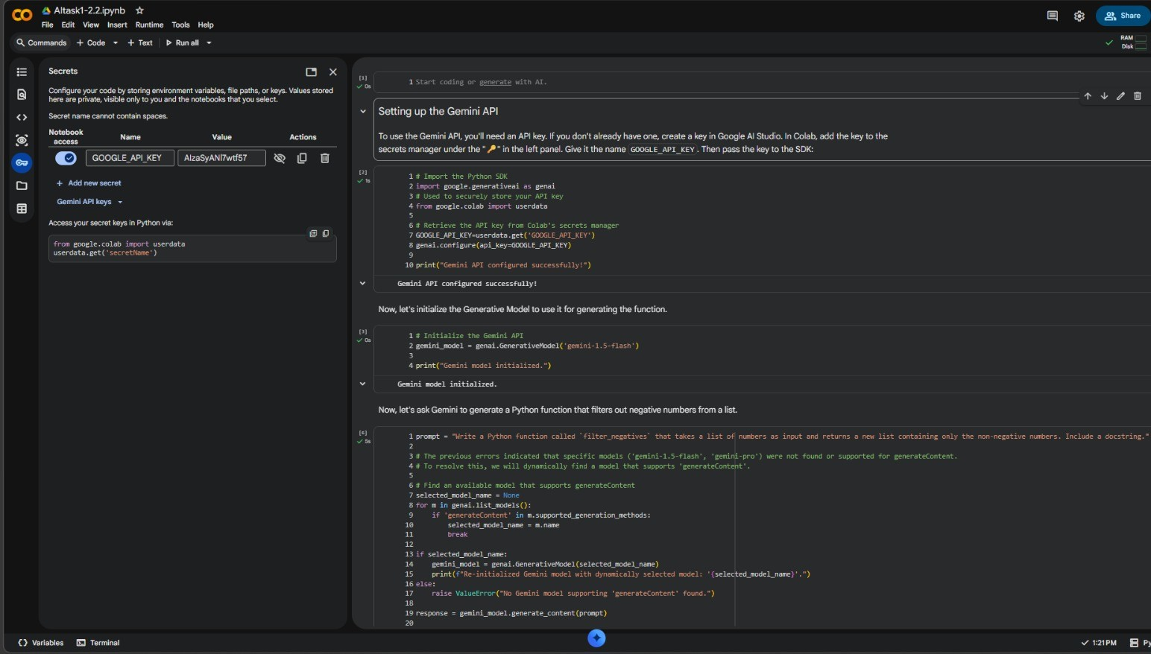
Task 2: String Character Analysis
❖ Scenario:
You are building a text-analysis feature.
❖ Task:
Use Gemini to generate a Python function that counts vowels, consonants,
and digits in a string.
❖ Expected Output:
➢ Working function
➢ Sample inputs and outputs
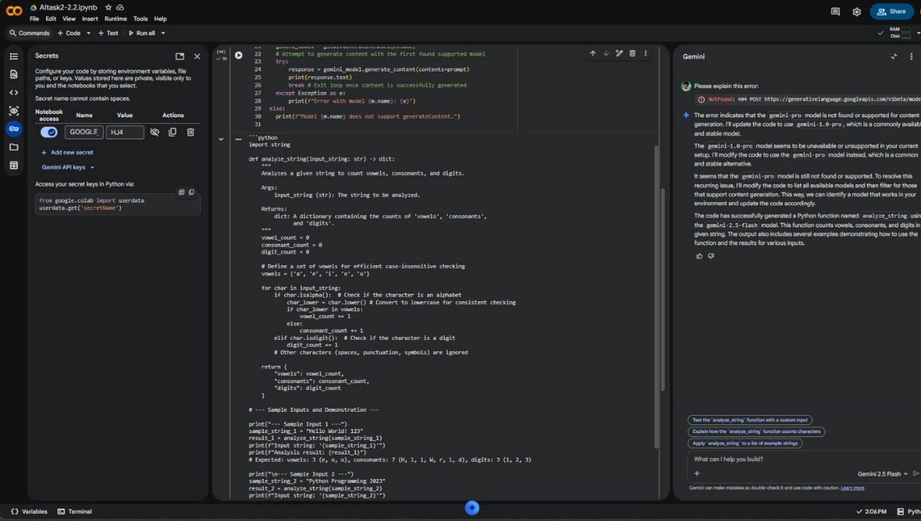

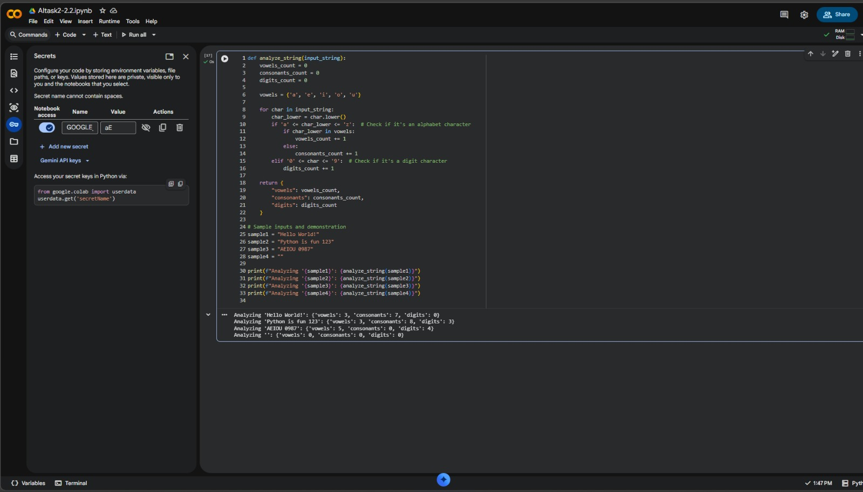
Task 3: Palindrome Check – Tool Comparison
❖ Scenario:
You must decide which AI tool is clearer for string logic.
❖ Task:
Generate a palindrome-checking function using Gemini and Copilot, then
compare the results.
❖ Expected Output:
➢ Side-by-side code comparison
➢ Observations on clarity and structure

Feature | Google Gemini (Colab) | GitHub Copilot / Cursor AI
Logic Approach | Often uses string == string[::-1] (slicing) for simplicity. | Often provides more "robust" versions, sometimes using reversed() or loops.
Documentation | Provides conversational explanations and usage examples. | Provides inline docstrings and focuses on integration within the IDE.
Conciseness | Very concise, aims for readability. | Aims for production-readiness (handling edge cases like spaces/case).

Task 4: Code Explanation Using AI
❖ Scenario:
You are reviewing unfamiliar code written by another developer.
❖ Task:
Ask Gemini to explain a Python function (prime check OR palindrome
check) line by line.
❖ Expected Output:
➢ Code snippet
➢ AI explanation
➢ Student comments on understanding
